Manual Testing | 01 | Introduction to Software Testing | Tamil | Absolute beginner guide

Software Testing is one of the crucial aspect of any software development process. To err is human and software is no exception. We will definitely have a lot of bugs and it is the responsibility of the tester to find and report the bug.

In this video, we will learn

1. What is software Testing?

2. Why do we need software Testing?

Software -> code written in any language, the end user using those code/products is called software
Eg ->whatsapp, FB, insta etc
Software Testing-> to make sure the products align with the requirement & no bugs present before hand over to end user
How a software is developed? ->SDLC(software development life cycle) ->(waterfall, agile)
SDLC
->Req analysis
->Design
->code
->test ->under test only STLC will come as below
->deploy
STLC(SDLC(software Testing life cycle) ->(waterfall, agile)
->Req analysis
->Test Planning
->Test case development
->Test environment setup (like QA or SIT etc)
->Test execution
Bug reporting
Retest
Regression testing
->Test cycle closure
Why we need to test the software?
To deliver a flawless product to the customer

Manual Testing Tutorial series | 02 | Black Box Testing | Tamil

Black Box testing is one of the most crucial thing and it's like a parent for almost all the testing that a QA team does fall under this category.
99% of the testing that QM team does comes under black box testing ...everyone in the world at least once done black box testing in real life[eg buying bulb we will test in store itself working or not]
What is a black box testing? Testing focus on the functional specification document
Black Box Testing is a software testing method in which the functionalities of software applications are tested without having knowledge of internal code structure and implementation details. Black Box Testing mainly focuses on input and output of software applications and it is entirely based on software requirements and specifications. It is done from the end user's perspective.
Eg..in epolicy application, i don’y know the internal code, just providing the input and validating the output(like policy created )
Same using watsapp, insta
Another example car driving, we know how to start, off, drive, AC..but internal code and hows work we don’t know
How to do black box testing?
1) Understand the end users requirements
2) Creating a test strategy
3) Designing the test cases with proper test case designing technique
4) Creating the test cases
5) Executing the test cases and
6) Raising a bug if any of the functionality is not working as expected All these come under STLC (Software Testing Lifecycle)
Types of Black Box Testing:
1. Functional
2. Non functional
3. Regression

Manual Testing Tutorials | 03 | White Box Testing | Unit Testing | Tamil

White Box Testing[also unit testing] is software testing technique in which internal structure, design and coding of software are tested.
Below are few important white box testing techniques.
1) Statement Coverage
2) Decision Coverage
3) Branch Coverage
4) Condition Coverage
5) Multiple Condition Coverage
6) Path Coverage
7) Control flow testing
8) Data flow testing.
In white box testing, code is visible to testers so it is also called Clear box testing, Open box testing, Transparent box testing, Code-based testing and Glass box testing.

White box testing or unit testing will be done by developer only..he will check
- Each and every function in the code
- Loop
- Condition statement
- Excepted ouput
- Any loop hole in the code which led to security threat

Manual Testing Tutorials | 04 | Functional testing vs Non functional Testing | Tamil

Function -> means working so functional testing means software working as per functional requirements
Functional testing is a type of software testing that validates the software system against the functional requirements/specifications. The purpose of Functional test is to test each and every functionality of the software application, by providing appropriate input, verifying the output against the Functional requirements.
Non Functional testing does not bother about the functionality whereas it focuses more on the Performance, reliability, scalability and other non-functional aspects of the software system. In fact, Non functional tests will be performed ONLY if the functional tests are passed. Load testing, stress testing, penetration testing are some examples of Non functional testing.

Functional testing-> car start, off, drive, backward, light on AC all tested as per functional req
Non Functional testing-> check the Performance, mileage in city, highway, with & without AC, more no of people inside

Manual Testing Tutorials | 05 | What is Smoke Testing | Tamil

What is smoke Testing?
⭐ Smoke Testing is a software testing process to identify whether the given software build is STABLE or not.
⭐ It is like an entry gate which determines whether the further rounds of testing can be done or not for the given build.
⭐ Under smoke Testing the core functionalities for the application will be tested and if and only if the essential portions are working fine, rest of the components will be put under test.
⭐ Smoke testing is also known as "confidence testing, BVT (Build Verification Testing), Build Acceptance Test, Tester Acceptance Testing NOT to be confused with User Acceptance Test.
Why do we need to do smoke testing?
To save effort and time before doing any regression. If the smoke tests are failed then there is no point in executing the whole regression.
A sample flow for Smoke Testing:
Dev team releases build ⬇️
QA team performs test on critical components ⬇️
IF Build is stable
⬇️ further testing (Functional testing)
(or) IF build is unstable
⬇️ sent back to developer.

Manual Testing Tutorials | 06 | Sanity Testing | Smoke Testing vs Sanity Testing | Tamil

What is Sanity Testing?
👉 Sanity testing is a Software Testing performed after receiving a software build, with minor changes in code, or new functionality, or after a bug fix. the main aim of this testing to assure that the new functionality is working fine no further issues are introduced due to these changes. The main difference between Smoke and Sanity is, Smoke will test the critical components across the build whereas Sanity will test the rationality of the particular module which went through a change or a bug fix.
👉 Sanity can be considered as a subset of Regression Testing.
👉 In general, Sanity testing is considered to be an undocumented process, but nowadays, companies are following a practice of adding test cases for the bugs identified, so if the sanity testing is after a bug fix, most likely it will be a documented process.

Manual Testing Tutorials | 07 | What is Regression Testing | Tamil

Whenever a new built came, testing E2E entire system is working or not..
Make sure all exciting functionality of the system working fine because of new built..

Manual Testing Tutorials | 08 | What is Retesting | Retesting vs Regression Testing | Tamil

what is Retesting?
👉 Retesting is a process to check specific test cases that are failed due to bug/s in the previous execution is getting passed or not in the next execution done after the big fix.
👉 Generally, testers find these bugs while testing the software application and assign it to the developers to fix it. Then the developers fix the bug/s and assign it back to the testers for verification. This continuous process is called Retesting.
⭐ Key difference between Regression and Retest:
👉 Regression will check if any other modules across the entire system is affected due to a code change or bug fix or new addition of functionality.
👉 Retesting is just focusing on a particular failure test scenario due to a bug and verify it again after the bug fix.

Manual Testing Tutorials | 09 | What is Adhoc Testing | Tamil

What is adhoc testing? Impromptu is a synonym for Adhoc, which means anything that is done without being planned, organized, or rehearsed.
In software testing, adhoc testing is testing an application randomly by using logical or illogical scenarios and check whether the application has any bugs or not. The primary goal of Adhoc testing is to break the software application by any means.
It is a negative and unplanned testing. As a result, it doesn't have any sort of documentation to be followed.
Adhoc testing can be classified into three further types: Buddy Testing[Dev + Tester wil do], Pair Testing[ 2 or more tester pair and do], Monkey or Gorilla Testing.[anything like monkey wil do in application and check]

Manual Testing Tutorials | 10 | Defect Vs Bug | Tamil
One of the most confusing and debated topics in the software testing field is the difference between the defect and the bug. Or actually is there any difference between them?
In my opinion, there are no differences. These words may have had different meanings in the past, but when Agile is in picture, both of these words mean one thing, that is "the feature is not working as expected and there is a deviation between the actual and the expected behavior".
Let me know your thoughts, on what's the difference between a Defect and a bug? Are they same or different? If different HOW?
Both are same only ->definition is -> A deviation between actual and expected behaviour of the application is called defect or bug
In jira, the name is bug , but in HP alm the name is defect...

Manual Testing Tutorials | 11 | Bug lifecycle Explained | Tamil

In this video, we will be learning the entire lifecycle of a bug right from the beginning.
When the tester finds and reports a bug, it is going through many states like
👉 New/Open: When a new defect is logged and posted for the first time. It is assigned a status as NEW or an Open issue which is yet to be assigned.
👉 Assigned: Once the bug is posted by the tester it is then assigned to the corresponding developer team.
👉 In progress: When the Dev team is working on providing the fix, the status will be marked as In Progress.
👉 Fixed: When a developer makes a necessary code change and verifies the change, he or she can make bug status as "Fixed."
👉 Retest: Tester does the retesting of the code at this stage to check whether the defect is fixed by the developer or not and changes the status to "Re-test." 👉 Closed: When the fix is given, the tester retests the fix and if its fixed, the tester will close the issue.
👉 Re-Open: If the defect is not fixed then the tester reopens the fixed issue and the dev team has to give the fix and this cycle will go on until the issue is closed.
Now in jira in my project
To do->In Analyis(dev do analysis and move to ticket to Duplicate ->Not reproduce->Rejected->deferred, if ticket valid then ready to dev)->Ready for development ->In developed ->Ready for QA-> Done
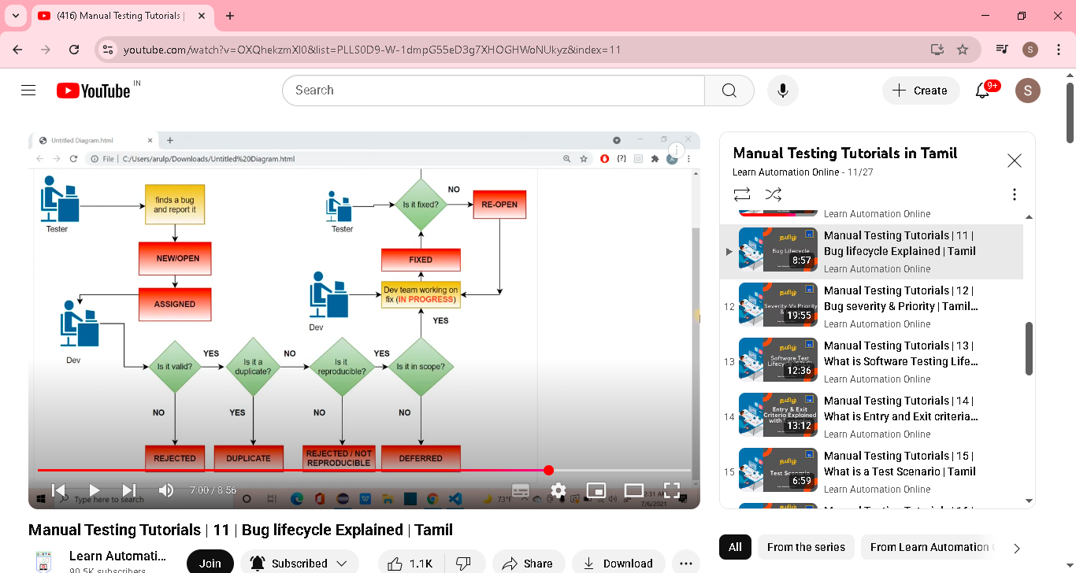
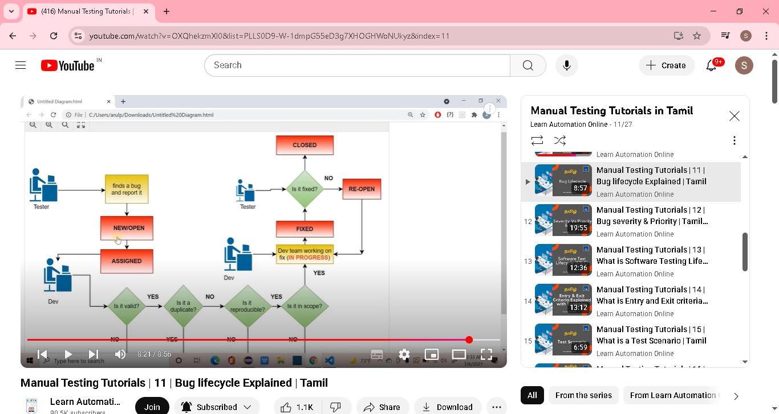

Manual Testing Tutorials | 12 | Bug severity & Priority | Tamil | Levels of Severity & Priority

What is Severity?
It is a measure, to indicate the impact of a bug/defect can have on the software product.
Based on the threat it causes to the product, severity is categorized into below
1. Low 2. Minor 3. Major 4. critical
What is Priority?
Bug priority refers to how urgently a bug needs to be fixed.
Levels of bug priority: =======================
Low: Bug can be fixed at a later date. Other, more serious bugs take priority
Medium: Bug can be fixed in the normal course of development and testing.
High: Bug must be resolved at the earliest as it affects the system adversely.
In most of the cases, severity and Priority are directly proportional. That is,
High Severity and High Priority:
==========================================
Example: Let's say google search button is missing on Edge/firefox . Only chrome users can search and firefox users can't. This means there is a potential loss of people using google search engine.
Low Severity and Low priority ==============================
Example: Let's say if there are lot of typos, font size, color mismatch etc. This is an issue, but it is not affecting the functionality of the product.
BUT, that is NOT always the case . A high severity bug can be a low priority one ==============================================
Example: Let's say a web application is working fine on the latest versions of most modern browsers. But on older versions and on legacy browsers, most elements are not interactable. This is a high severity bug, which affects the functionality but the percentage of people using these older versions could be very low, so it takes Low priority.
and A Low severity bug can be a high priority one. ============================================= Let's say Buy now button is not fit in the page for chrome, with 100% view. Only after setting the zoom size to 70%, the buy now button is visible. This Doesn't affect the functionality, the button is there and it works. But it affects the user experience of larger audience. Hence its a high priority one.

Manual Testing Tutorials | 13 | What is Software Testing Life Cycle | STLC | Tamil

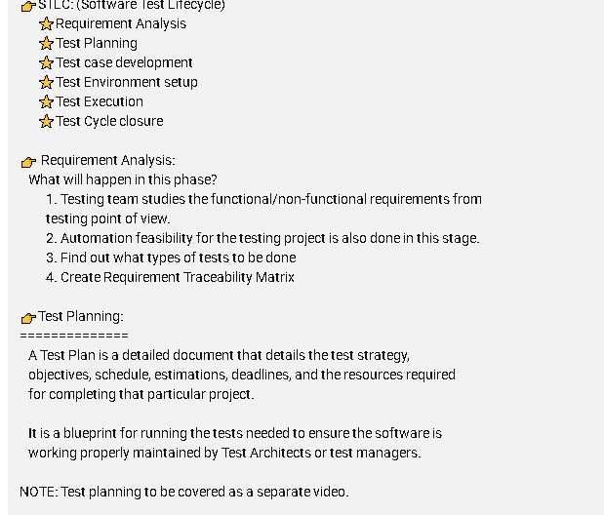

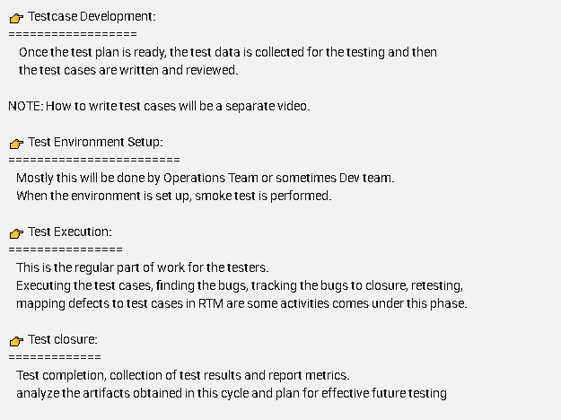

Once test strategy,estimation ready it will get review and sign off from client
Once test case ready it will get review and sign off from client
Test environment(QA,SIT,UAT)

Manual Testing Tutorials | 14 | What is Entry and Exit criteria | Example Templates | Tamil

Entry criteria: A set of conditions to be met/satisfied before an activity can begin.
Exit criteria: A set of conditions to be met/satisfied before an activity can be concluded. Both these criteria are applicable for all the phases of STLC.
Practically speaking, we can't follow the entry and exit criteria in a strict manner. In this video, I have explained how to write entry and exit criteria for different phases of Software Testing Lifecyle with examples.
To get the most out of my videos, try to create your own notes combining my video contents and your own research. Properly document them, you will be having a huge Knowledge artifact in no time.

Entry criteria example:
Below %, values based on project need & work culture
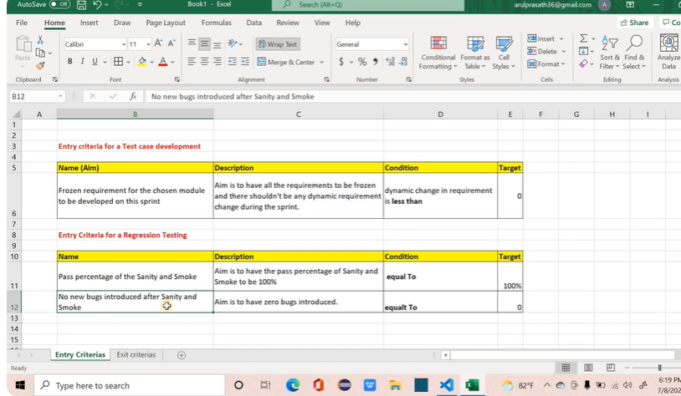

Exit criteria Examples:
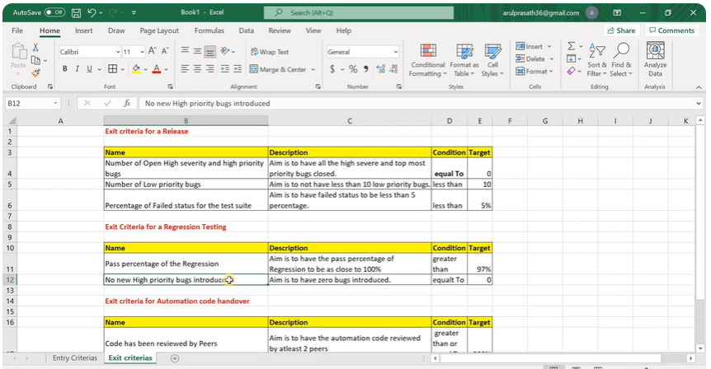
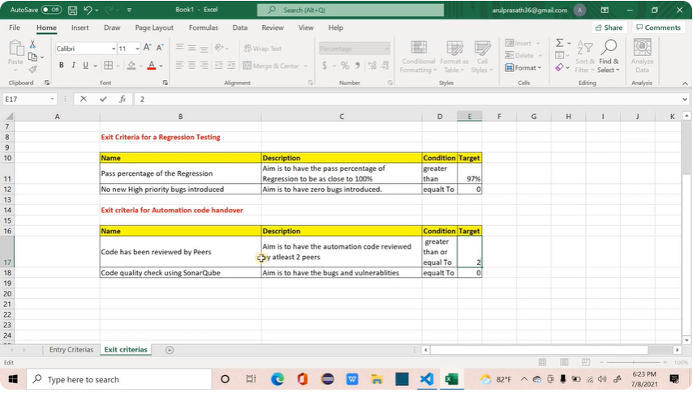

Manual Testing Tutorials | 15 | What is a Test Scenario | Tamil

✔️What is a test scenario? ->Just writing one line about the requirement we are going to test
It is a breakup of a business requirement, presented in form of possible use cases. With the help of scenarios we can provide more test coverage for the functionalities of the application
In simple words, it is a functionality to be tested.
✔️Examples:
✔️Check if the user is able to send multimedia files while chatting
✔️Check if the user is able to make an audio call
✔️Check if the user is able to put status
✔️Check if the user is NOT able to send files more than 300 MB through attachments.
These scenarios can be further split into test cases which contains steps on how to perform the tests
Adv:
It will Same time. some company prefer only test scenario, test case not needed
Drawback if you are writing only scenarios:
Imagine the feature files that we have written while learning Cucumber. Let’s say if we eliminate the Given, when, then statements from the scenario, we will be having only the name of the scenario and if someone is new to the system under test, he or she will not be aware of the steps to be followed with just the name of the scenario. In that case, test case will be most helpful.

Manual Testing Tutorials | 16 | Test case development real time example

What is a test case?
A step by step instruction written in a detailed manner with steps to be performed and expected result for any given functionality is called a Test case.
Where to write a test case?
In companies test cases are written in any of the Test Management Software like HP ALM, qTest, TestRail, Rally etc.
When you are a learner and if you refer any blogs or YouTube videos, you might have seen the test cases written in an excel file.
But, that will not give us a better satisfaction. We are going to use a free test management software called TestCollab.
In this video, we not only learn how to create test cases, we will be learning how a task will be created for test case development in jira, how the jira task and the test suite will be connected and so on. This is how exactly things will happen in real time. Kindly share it with your friends.
In some project ->under user story, they will pull all test cases under links & defect also as subtasks..all the test case , defect is closed..then we mark the user story as done
In our project ->we are using zephyr as test management tool
We are uploading the excel tc to zephyr under cycle summary & execute the test case with pass, fail and map the defect accordingly
Prev project used seapine as test management tool

Note: we have option for time logging for subtask..where we upload the developed test case..
We can mention how many hrs or days or weeks spent to develop a test case for that user story..
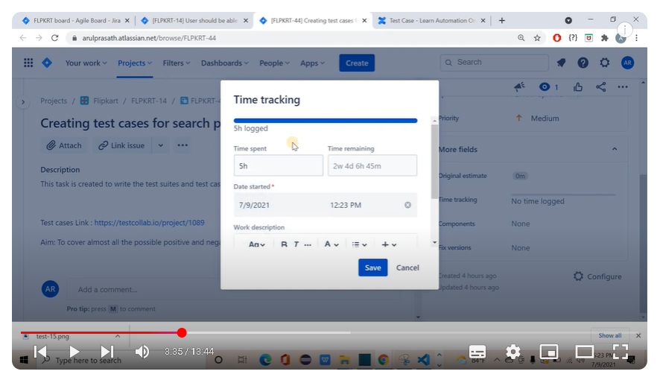

Manual Testing Tutorial | 17 |Test Execution | Effort logging | Mapping a bug to a test case | Tamil

How to log effort in Jira for the test case development or for any activity, how to execute the test cases and mark the status. How to report a bug and link the test case status with bug are few things that we will be discussing in this video.
We will create a bug and then map the bug to the test cases as you already worked in zephyr or hp alm

Manual Testing Tutorials | 18 |Requirements Traceability Matrix for Agile | How to create one| Tamil

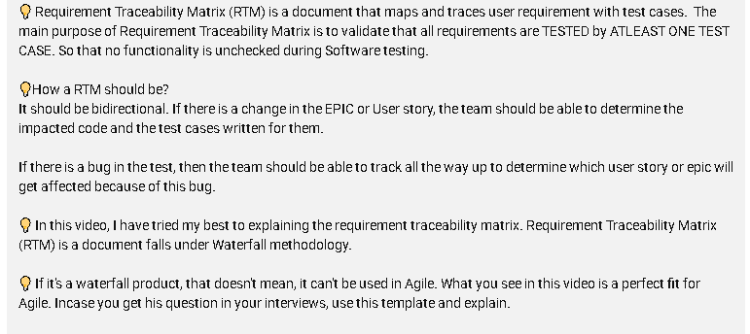
In agile, RTM is not needed because in jira board itself its all nested..eg buy map to the particular user story and test cases also map to the user story..its easy to track all under user story
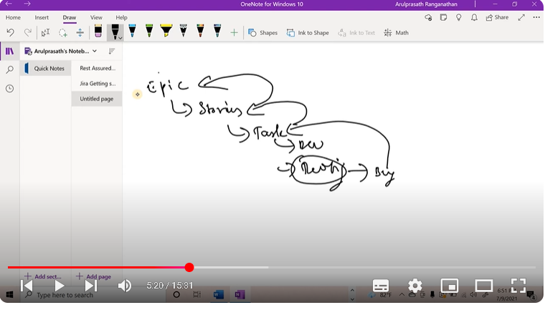

But we can create RTM for agile also as below
Note:
User story may spilt into subtask for easy dev and testing
Code column for dev knowledge..once buy identified we can directly go to tht particular package to fix
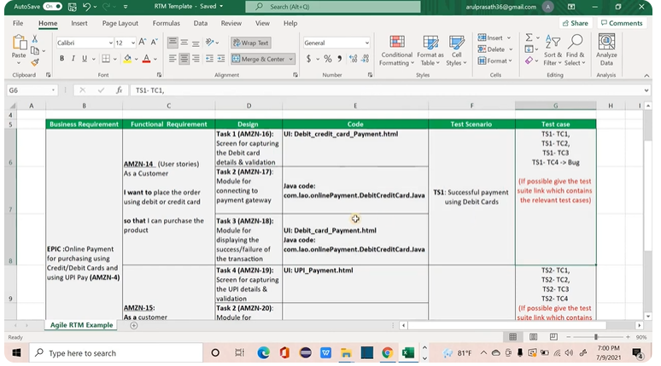

Manual Testing Tutorials | 19 | Testing Principles Explained | Tamil

Software Testing is a crucial process and we have to achieve optimal test results for having a better quality product. Getting deviated from the task we were supposed to do is a normal behavior. That’s why we have reminder apps, goal trackers etc. Software testing is no exception, we tend to deviate from the original goal often times and what makes the testers oriented towards their goals, what ensures that the team is following the correct strategy? Testing Principles.

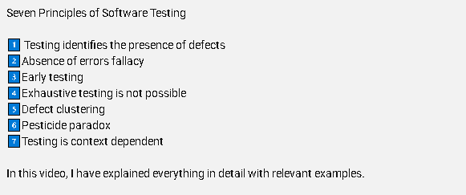

Exhaustive Testing eg below

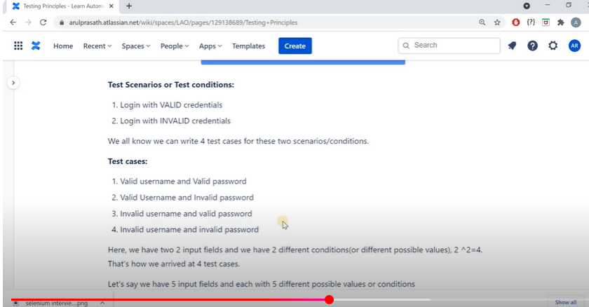

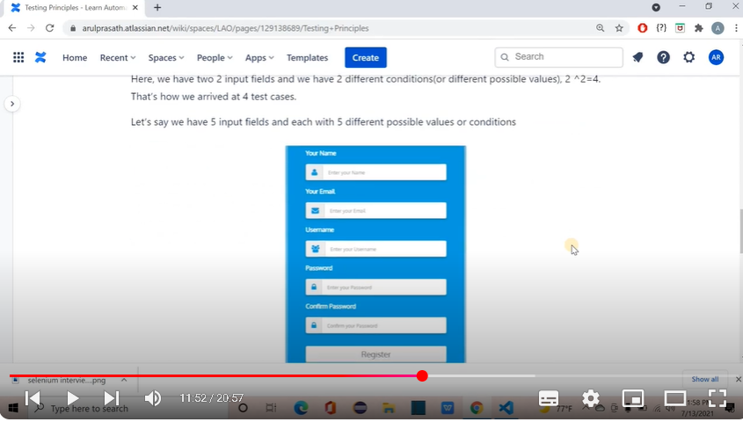

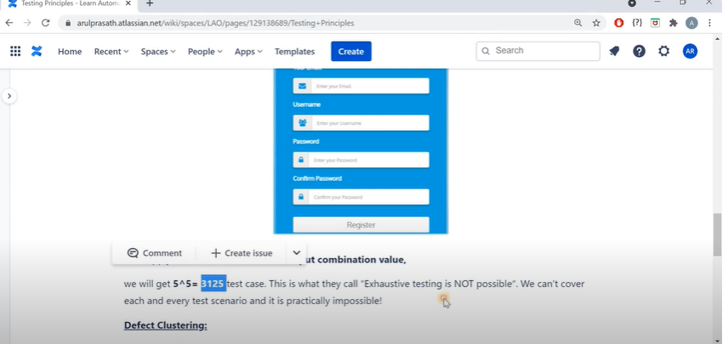

In RAD testing, it not possible to test all condition of test data present in HUOn moved to PDF..its possible..dont have time to write TC and execution..that why Exhaustive Testing is not possible

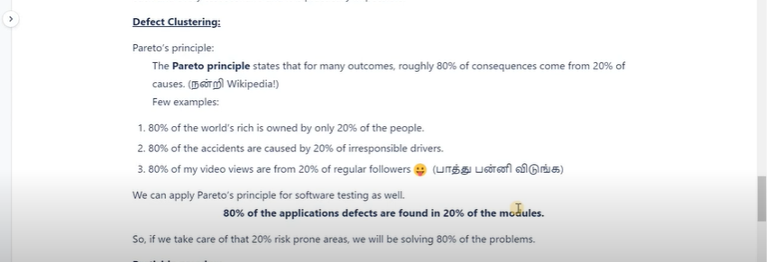

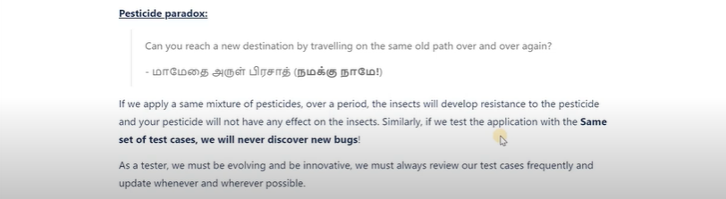

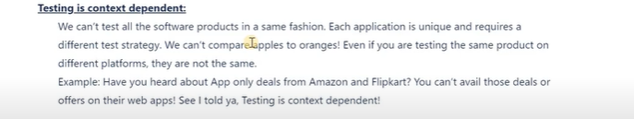

Manual Testing Tutorials | 20 | Agile Testing Principles | Tamil

Traditionally, testing was a separate activity that came after the coding phase;
in agile, testing is a continuous process. Testers are placed between product owners and developers. This creates an ongoing feedback loop which helps developers improve their code.
Key concepts of Agile Testing:
Communication with product owners
Close interaction with developers
The entire team is involved in quality assurance
Ten Principles of Agile testing as explained in the book Agile Testing: A Practical Guide for Testers and Agile Teams, Lisa Crispin and Janet Gregory
Deliver value to the customer.
Provide continuous feedback (It should be Quick Feedback as well, IMO)
Enable face-to-face communication
Have courage
Keep it simple
Respond to change
Practice continuous improvement
Self-organize
Focus on people
Enjoy
I would like to add one more principle
Less documentation

Manual Testing Tutorials | 21 | Why do we need Test case design techniques ? | Tamil

Covering all possible scenarios with all possible test data for any given functionalities is a HERCULEAN TASK. In real world no tester would be able to write and execute test cases for all the possible test cases with the entire set of possible data.

So How to provide a maximum amount of test coverage?

That is where test case design techniques comes into picture. Test case design techniques allow us to create or design effective set of test cases for maximum test coverage. The beauty here is, test design techniques not only provide us the effective set of test cases, it also reduces the number of test cases to a greater extent.

In this video, I have explained why a test design technique is required with a banking module example. We will also be doing a task of identifying the possible number of test cases for the given module, identifying some valid and invalid test data, finding how long will it take to execute the identified test cases.
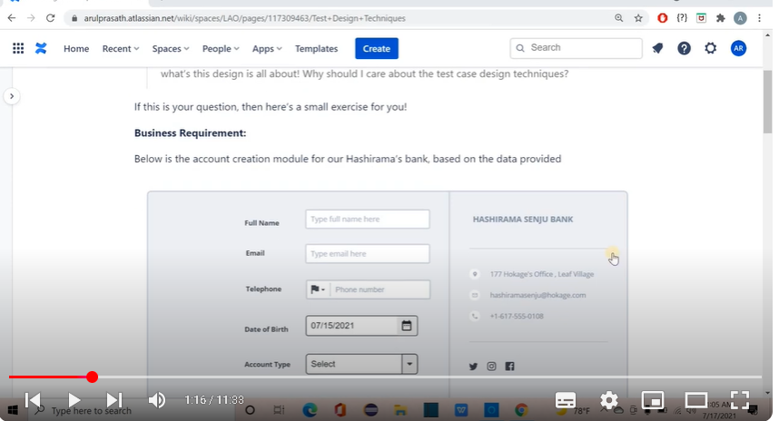

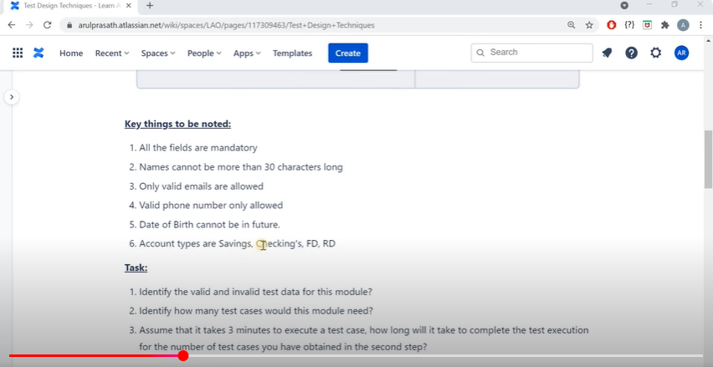

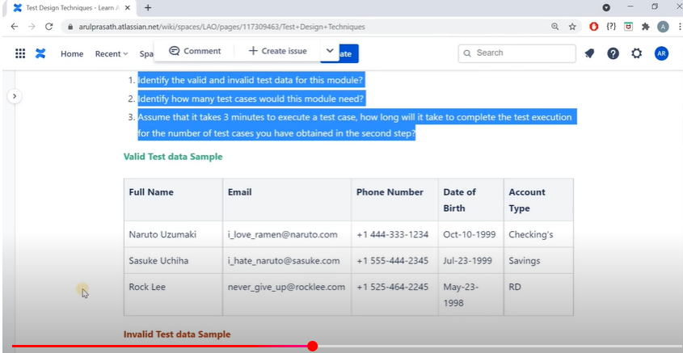

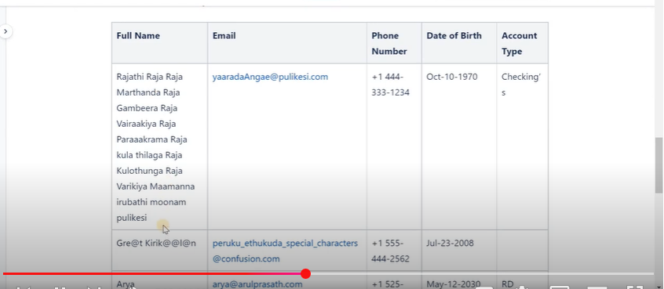

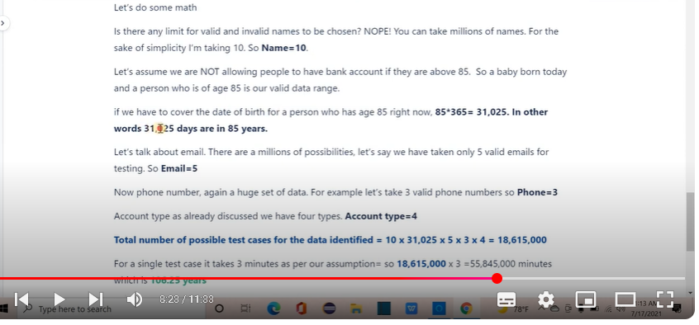

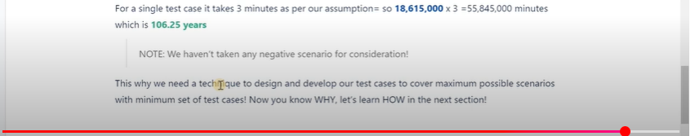

Manual Testing tutorials | 22 | Types of Test design techniques and Equivalence Partitioning | Tamil

Equivalence partitioning is also known as “Equivalence Class Partitioning”.
The whole range of input data for a given requirement are grouped into several sets or equivalence classes.
Equivalence classes are determined in such a way that all the input values in a input data range produce the same output when it is processed by the software.
Using this, we can eliminate Exhaustive testing.
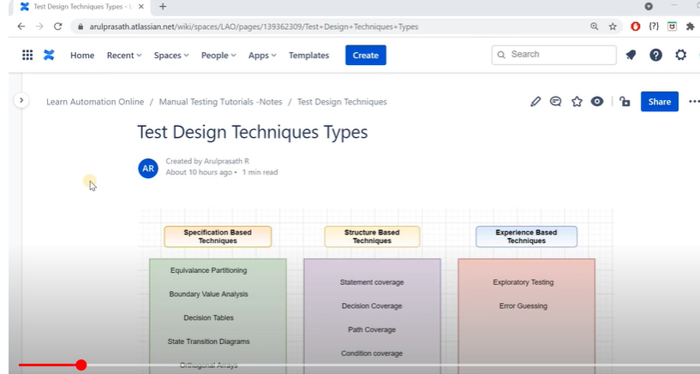

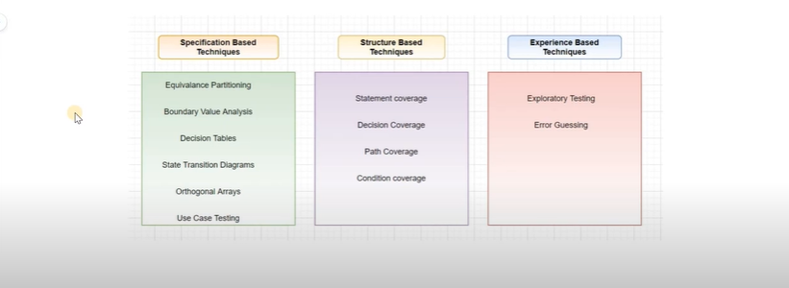

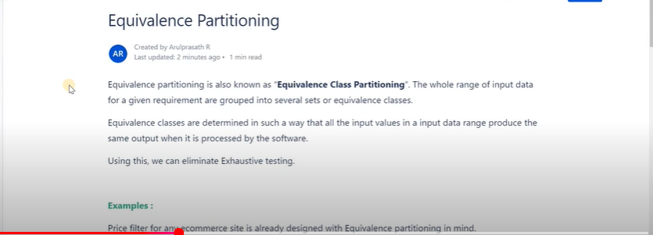

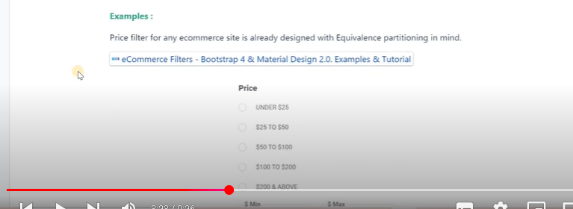

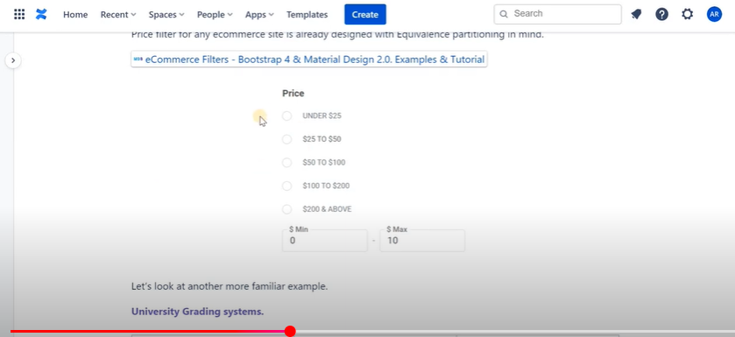

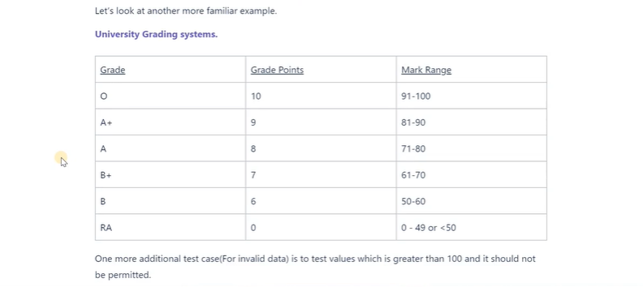

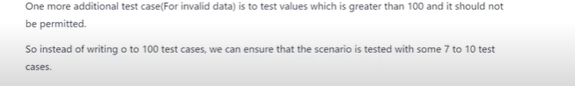
Here instead of writing 100 test case , we are tested with 7 to 10 test case with the help of portioning the test data..
Eg 91to 100, only one test data we can test..

Manual Testing Tutorials | 23 | Boundary value analysis | Tamil

Boundary value analysis is used for developing test cases to test the boundaries which separates the continuous range of inputs. The boundaries are identified as part of this technique and then the test cases are written. For any scenario, we can write
Lower boundary cases (using values just below the boundary specified)
Upper Boundary cases (Using values just above the boundary specified)
On boundary cases (Using the boundary values)
Formula for finding the lower, upper and on boundary cases: min-1, min, min+1, max, max-1, max+1
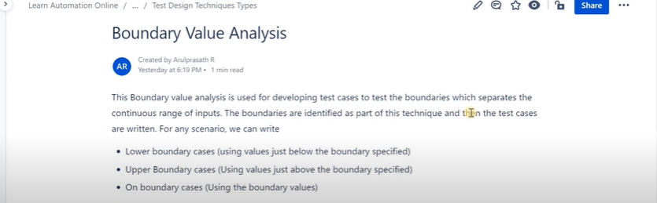
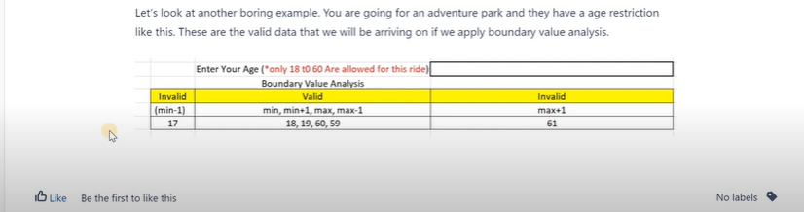
With this we can reduce the no of test case with maximum effective coverage..bec not possible to test all age group

Manual Testing Tutorials | 24 | Decision Table Technique | Tamil

Decision table is one of the testing design techniques which will help us test the system’s behavior with various set of inputs.
This technique can also be called as Cause and Effect table, as it captures the driving factor (cause, input data) and the captures the effect (output) in the tabular format.
Few things to remember:
The entire team can understand the nature of the application by simply looking at the table.
Provides a better test coverage for any given functionality.
Any type of complex requirements can easily be turned into decision tables and one thing to remember when the number of input conditions is higher the table will become large and will be difficult to manage. In that case we can rely on equivalence partitioning or Boundary value analysis.

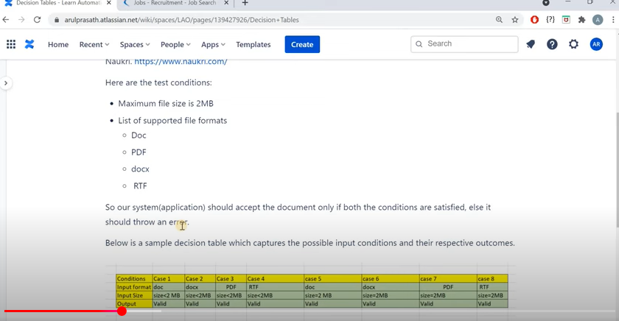

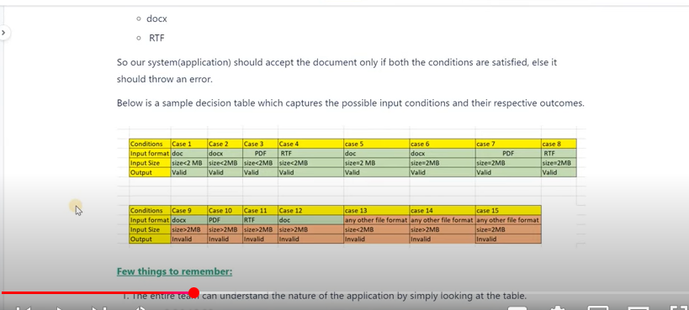

Manual Testing Tutorials | 25 | State Transition Technique | Tamil

Test design is not just giving valid and invalid inputs and calculate the number of test cases to be written. Sometimes, the test structures are not simple to demonstrate them using input and output combination.
In such cases, we will be interested in knowing the state of an application for any given input and how the state is getting transitioned from one to another.
When talking about state transition, we need to understand four things.
State
Transitions
Events
Actions
All these are explained with an appropriate example in this video.
First example
Off,on->State
Turn on the switch ->event
Off to on change ->transition
Actions wil be see next example
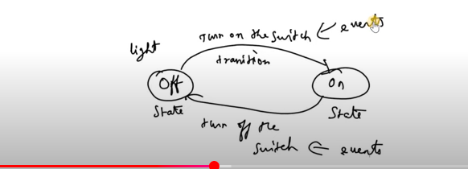
Another example
Here action ->insuffient payment popup beep to the user
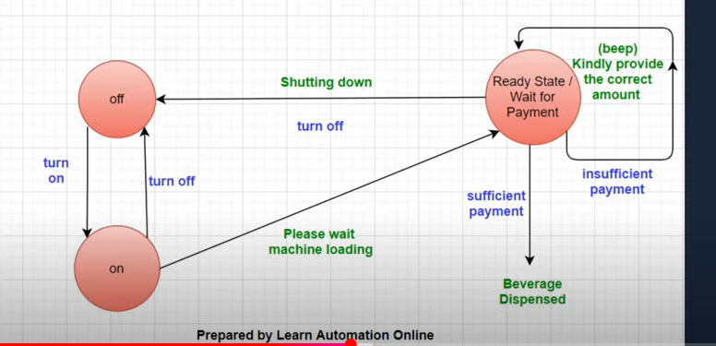
By seeing the diagram or state transition flow, we can easily understand the application flow and provide better coverage with all scenario

Manual Testing Tutorials | 26 | Use case Testing Technique | Tamil
Use case is much like a older brother to user stories. Use case is a process of defining the actions done by the actors/users on the System(software) and the responses of the system for the corresponding action.
Use Case Testing is a software testing technique helps to identify test cases which covers the entire system on a transaction by transaction basis from start to end. By transaction by transaction I mean,
For Every action on the software done by the ACTOR
There’s a REACTION from the software (SYSTEM)

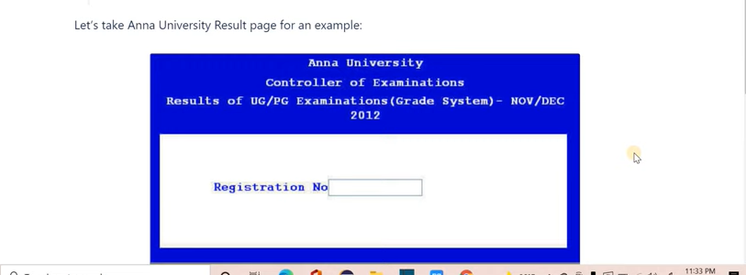

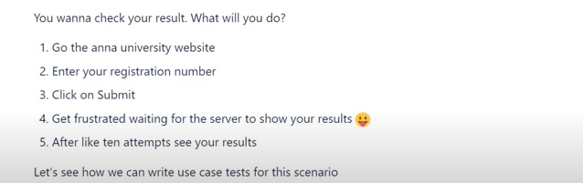

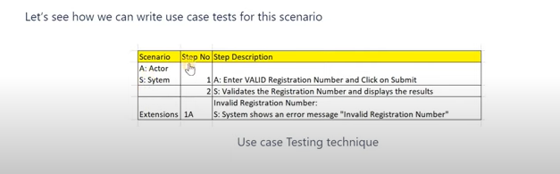

Manual Testing Tutorials | 27 | Error Guessing Technique | Tamil

Error guessing is a method of black box testing that relies solely on the previous experience of the tester. The software tester uses their past experience to determine where errors in the software may be.
Few example scenarios:
division by zero entering
blank spaces into text fields
entering invalid values
submitting without value specification
uploading files that exceed the set limits

